Computer Organization and Architecture
Name: Pallav Biyala Course: Computer Organization and Architecture
Roll No.: 24110234 Date: 13th February, 2025
Assignment – II
Q1 Write a function in MIPS32 assembly that computes the Highest value & index, Lowest value & index and Average value of an Array arr [100]. Assume the base address of Array arr is available at $gp. The results will be stored at $v0, $v1, $s0, $s1 and Ss2.
Sol 1: So before going to MIPS Assembly, lets just first write the code in high level language. So here we can choose either C or C++. For convenience, we will stick to C++.
The high level code for the following function would be:
vector<int> find(vector<int> &arr, int n){
int max_idx = 0;
int max = arr[0];
int min_idx = 0;
int min = arr[0];
int sum = 0;

for (int i = 0; i<n; ++i){
// finding max
if (arr[i]>max){
max = arr[i];
max_idx = i;
}

// finding min
if (min>arr[i]){
min = arr[i];
min_idx = i;
}

// finding sum
sum += arr[i];
}

vector <int> result = {max,max_idx,min,min_idx,sum / n};
return result;
}

Hence, lets convert it to assembly. We are given:
- arr is available at $gp.
- The results will be stored at $v0, $v1, $s0, $s1 and $s2.
- So let’s store:
    - max $v0
    - min $v1
    - max_idx $s0
    - min_idx $s1
    - average $s2
So the assembly code would be:
Assembly Code:
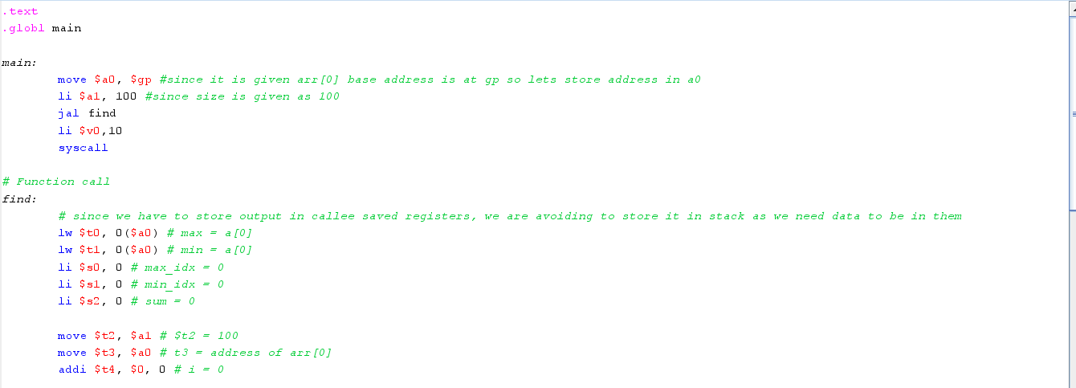
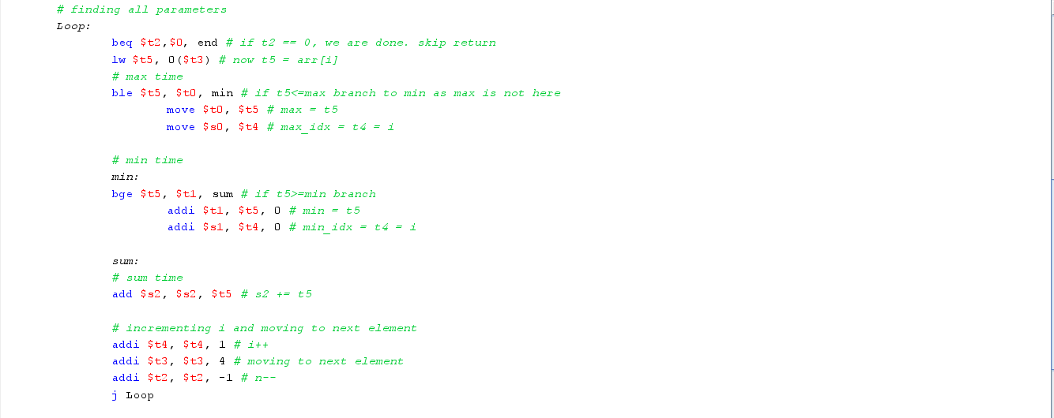
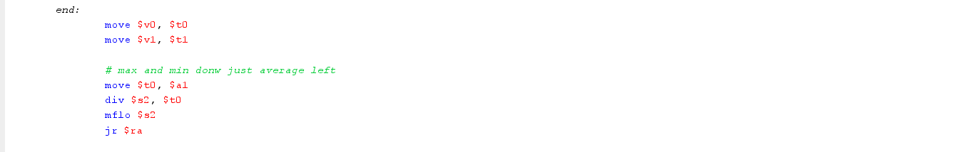
Q2 MIPS program to add two matrices A and B of size N x N and store the result in C, where N is 4. You may please check on how to initialize the matrix on a given simulator.
Sol. 2: The C++ code to add two matrices A and B is:
C++ Code:
#include <iostream>
using namespace std;

vector<vector<int>> sum_matrix(vector<vector<int>> &A, vector<vector<int>>&B){
int n = A.size();
vector<vector<int>> sum(n, vector<int> (n,0));

for (int i = 0; i<n; ++i){
for (int j = 0; j<n;++j){
sum[i][j] = A[i][j]+B[i][j];
}
}
return sum;
}

int main()
{

return 0;
}

So to access each element address, we would have only base address of A[0][0] or B[0][0]. So to simplify logic, we know memory is just a contiguous block of memory. Hence, we can consider a 2D matrix as a flattened array. Hence lets say:
Assumptions:
- Size of matrix is 3 * 3, hence 9 elements so 36 bytes storage needed.
- Base address of A is being pointed by $gp.
- Base address of B is at 40($gp)
- Base address of result would be at 80($gp)
- N is stored at 120($gp)
So we can maintain a register for A, for B and for result and every time move it by 4 bytes. By this way, we could keep track of all corresponding elements and we won’t require external logic too!
Now we can easily write assembly code:
Assembly:

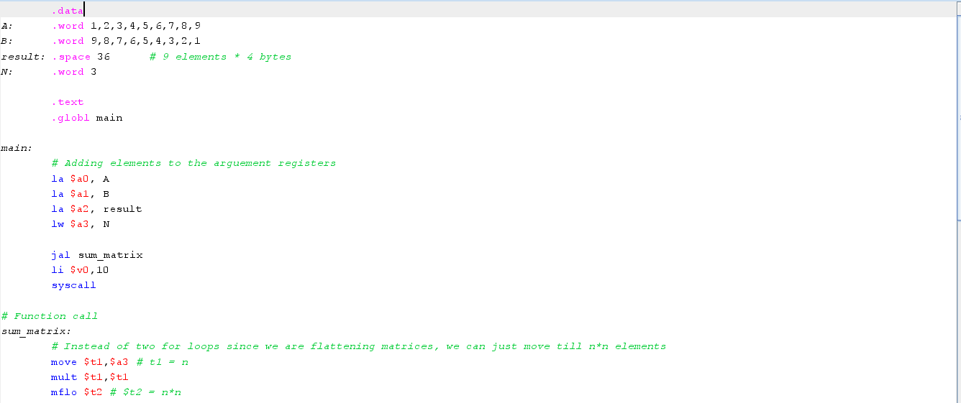
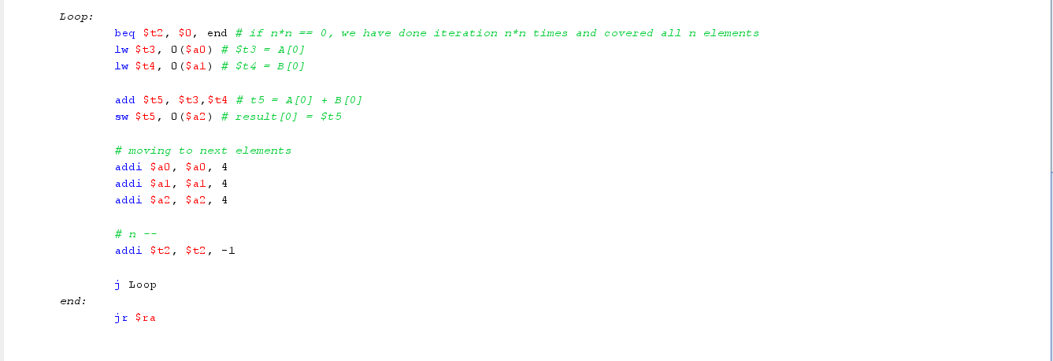
Hence, here to simplify problem we considered the fact that we have N*N matrices and memory is contagious block of elements, and hence we can flatten the matrices and then simply add them.
Q3 Implement a quick sort in MIPS.
Sol. 3: The C++ code for the quick sort is:

class quicksort{
private:
void swap(int &a, int &b){
int temp = a;
a = b;
b = temp;
}

int partition(vector<int>&arr, int low, int high){
int pivot = arr[high]; // taking pivot as high element
int i = low-1;

for (int j = low; j< high; ++j){
if (arr[j] <= pivot){
i++;
swap(arr[i],arr[j]);
}
}
swap(arr[i+1], arr[high]);
return i+1;
}

void quicksort(vector<int>&arr, int low, int high){
if (low<high){
int p = partition(arr,low,high); // p is at correct position now
quicksort(arr, low, p-1); // sort left half
quicksort(arr, p+1, high); // sort right half
}
}

public:
vector<int> sort(vector<int>&arr){
int n = arr.size();
quicksort(arr, 0, n-1);
}
};

Assembly:
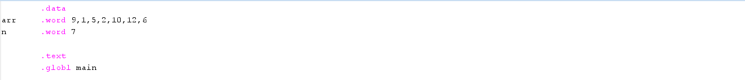
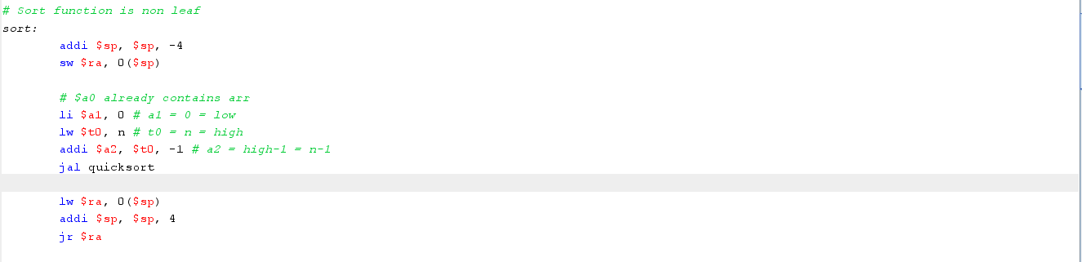
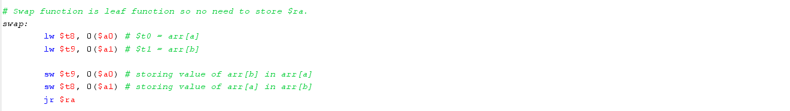
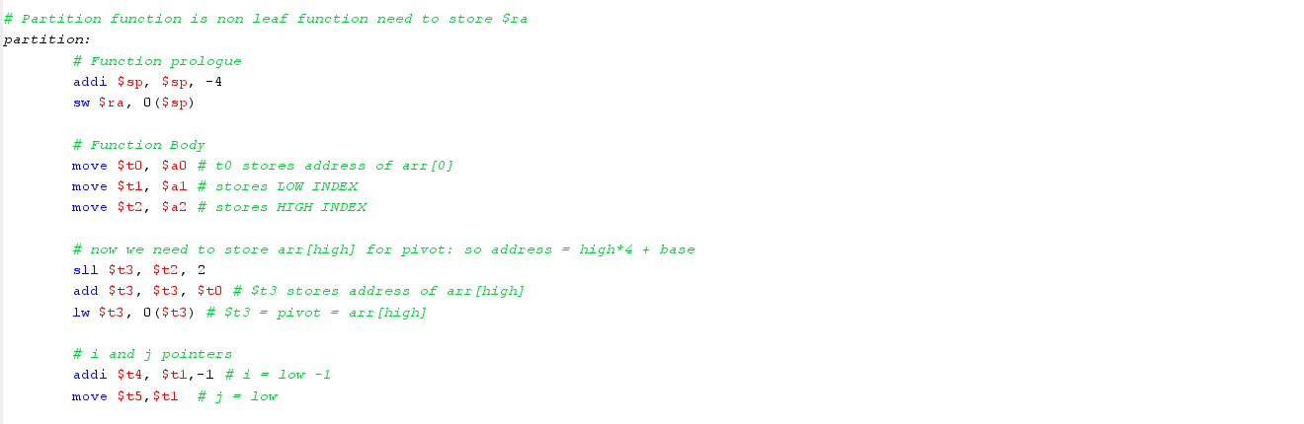
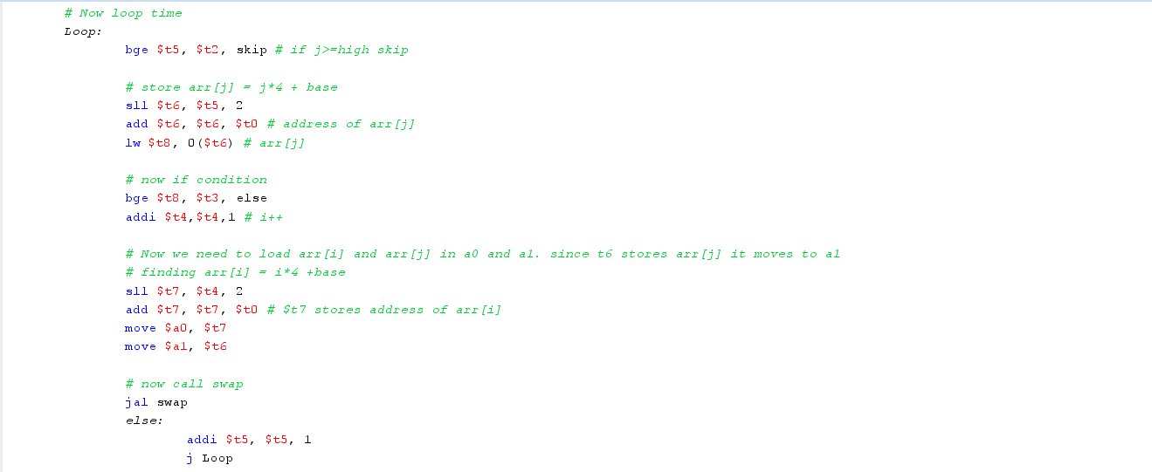
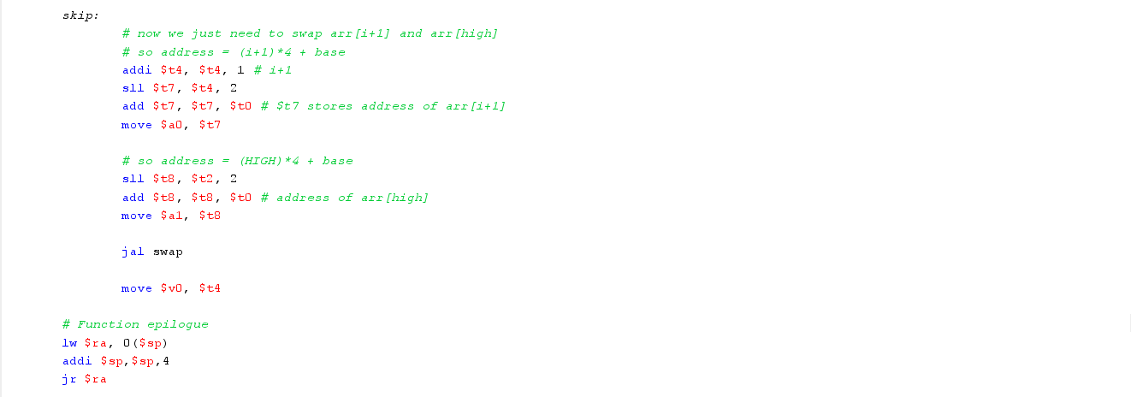

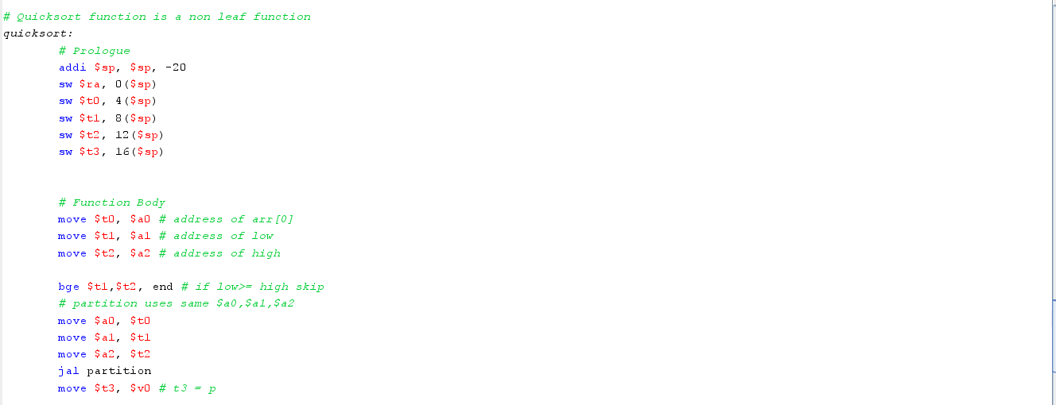
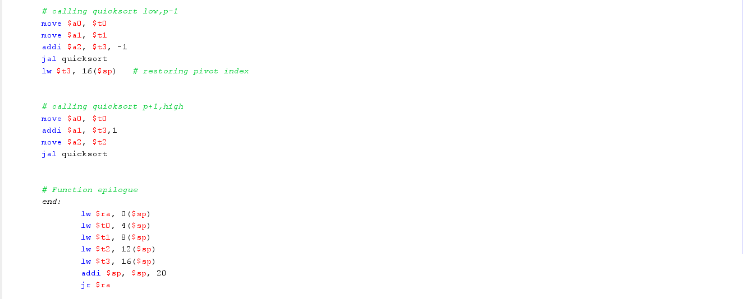
Q4 Write a MIPS program to perform a binary search on an existing and non-existing element a sorted Array A [10]
Sol. 4: The C++ code for binary code is:

bool binary_search(vector<int>&arr, int n, int k){
int low = 0;
int high = n - 1;

while (low<= high){
int mid = low + (high - low)/2;
if (arr[mid] == k){
return true;
}

else if (arr[mid]>k){
// search left
high = mid - 1;
}

else{
// search right
low = mid+1;
}
}
return false;
}

Assembly Code:
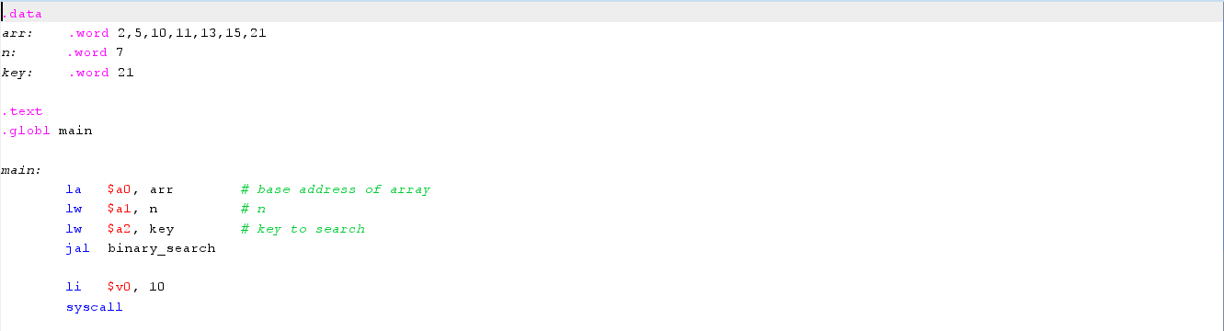
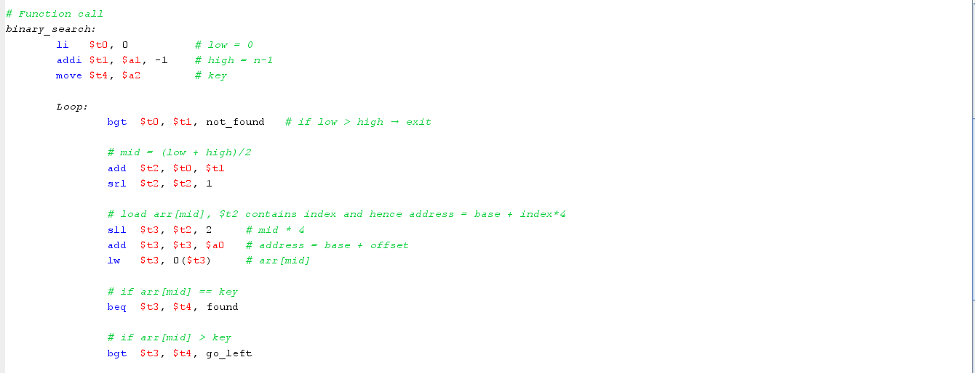
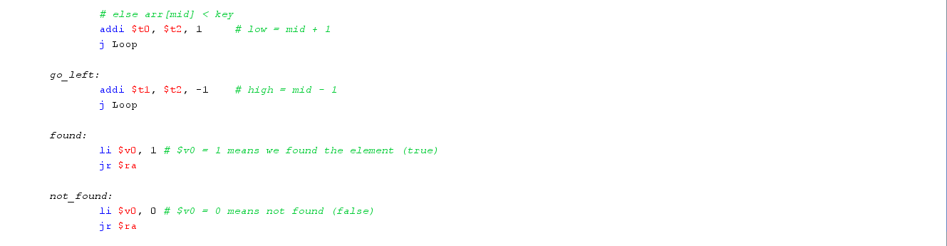
Q5 Write a MIPS program to multiply square matrices of size N x N where N is 5. Compare the code you wrote w.r.t the earlier version of the code (in Assignment 1) generated by the compiler when N is set to 5. What differences do you observe?
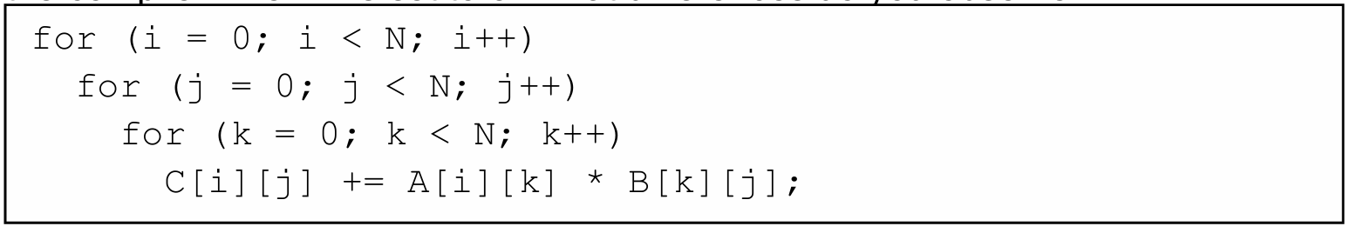
Sol. 5: The C++ code for this question is:
vector<vector<int>> matrix_multiplication(vector<vector<int>> &A, vector<vector<int>> &B, int n){
vector<vector<int>> result (n, vector<int> (n,0));

for (int i = 0; i<n;++i){
for (int j = 0; j<n;++j){
for (int k = 0; k<n; ++k){
result[i][j] += A[i][k]*B[k][j];
}
}
}

return result;
}

Now the main and hard thing here is to keep track of indices when we consider matrices as flattened. So now suppose we have a matrix:
A = $\left[ \begin{matrix}1 & 2 & 5 \\ 8 & 4 & 5 \\ 7 & 0 & 1\end{matrix}\right]$
Now when we flatten it:
A = [ 1 2 5 8 4 5 7 0 1]
So now let’s see how indices changed:
- [0][0] 0
- [0][1] 1
- [0][2] 2
- [1][0] 3
- [1][1] 4
- [1][2] 5
- [2][0] 6
- [2][1] 7
- [2][2] 8
So now for if i denotes row and j denotes column:
- For i = 0, index = j
- For i = 1, index = j + 3 (and basically n = 3 n + j)
- For i = 2, index = j + 6 = j + 2*3 (and this means index = n*i + j as here i was 2 and it works for all others)
Hence in general to find index of a matrix in a 2D array when flattened:
Index = n*i + j
And we know to know address of index in Memory:
Address = base address of arr[0] + index*4
Which gives:
Address = base + (n*i + j)*4
Hence we will need to play a lot with this equation!
Now, here:
We have n = 5, hence formula becomes:
Address = base + (5i + j)*4
So lets firstly map registers for convenience:
- i $s1
- j $s2
- k $s3
- n $s4
- $a0, $a1 Matrices base address of A,B
- $s0 Base address of Result
- $t5 sum
- $t1 A[i][k]
- $t3 B[k][j]
Rest all we can use for address calculation etc purposes, so even if those overwritten we don’t care.
Assembly Code:
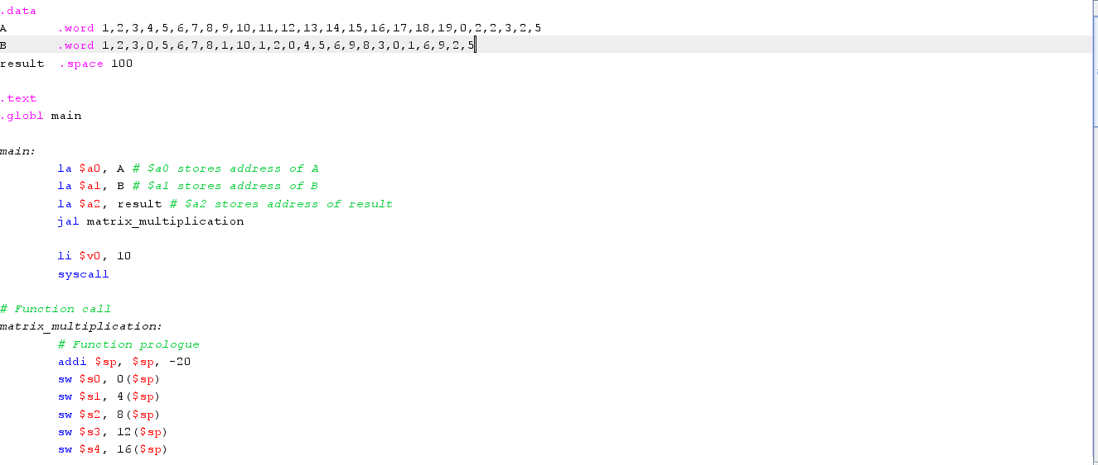
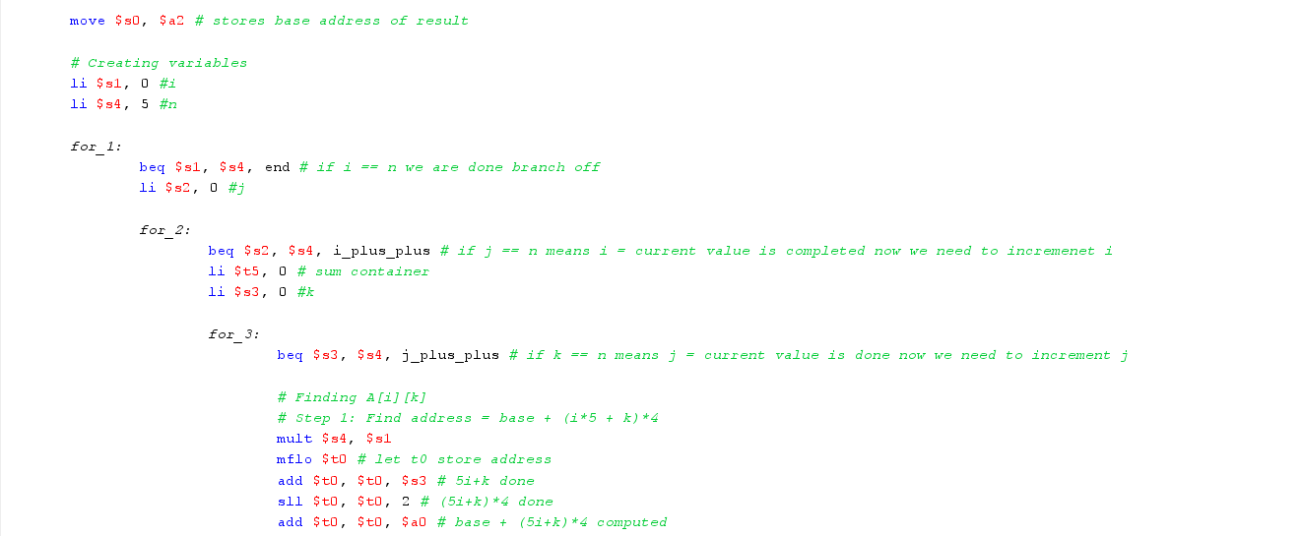
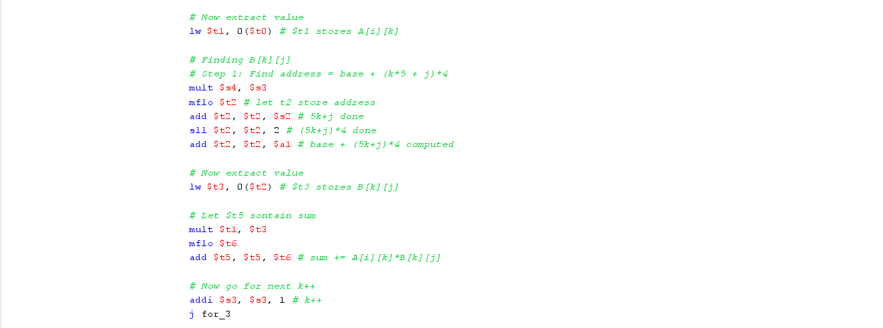
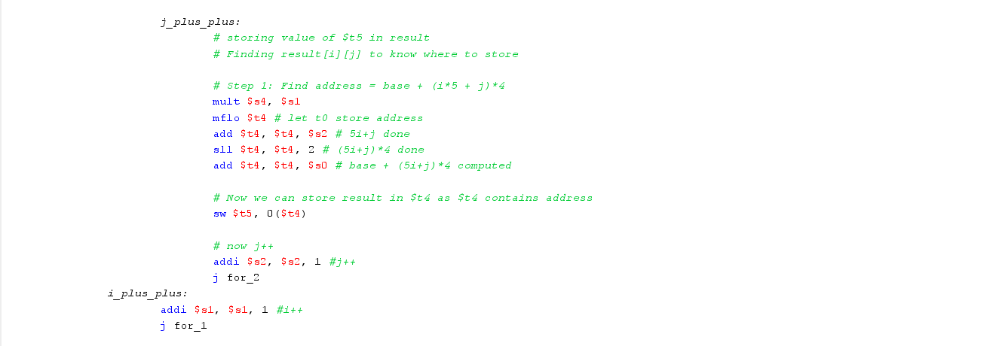
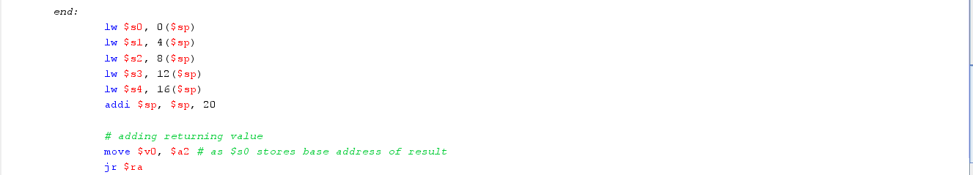
Comparison with Earlier Code generated by compiler:
So, if we compare our handwritten code with the compiler generated for same problem, we found out that:
- The compiler has written a huge amount of code with lines crossing 200 – 300 (no optimized across 400) lines of instructions. On the other hand, we used minimal 100 lines of codes with lots of spaces.
- Compiler has excessively used stack pointers, frame pointers and saved too many registers. While we ignored frame pointer and use stack pointer only to store callee saved registers.
- Compiler uses stack for loop variables while we did all loop in temporary registers, making sure that if value is needed, we don’t store it in it again
Hence, the compiler-generated code is significantly longer and uses more stack space compared to our assembly code.
The compiler saves additional registers, uses a frame pointer, and often stores loop variables in memory. Our implementation though keeps loop variables in registers and performs direct index calculations, making it shorter and more readable. The compiler-generated code is more general and adheres strictly to calling conventions, while the ours is optimized for clarity and a fixed matrix size and easier to understand.
Q6 Assemble the following instructions based on the MIPS data-card shared on MS teams. Assume the string “DEADEND0” is stored at the base address pointed by $gp.
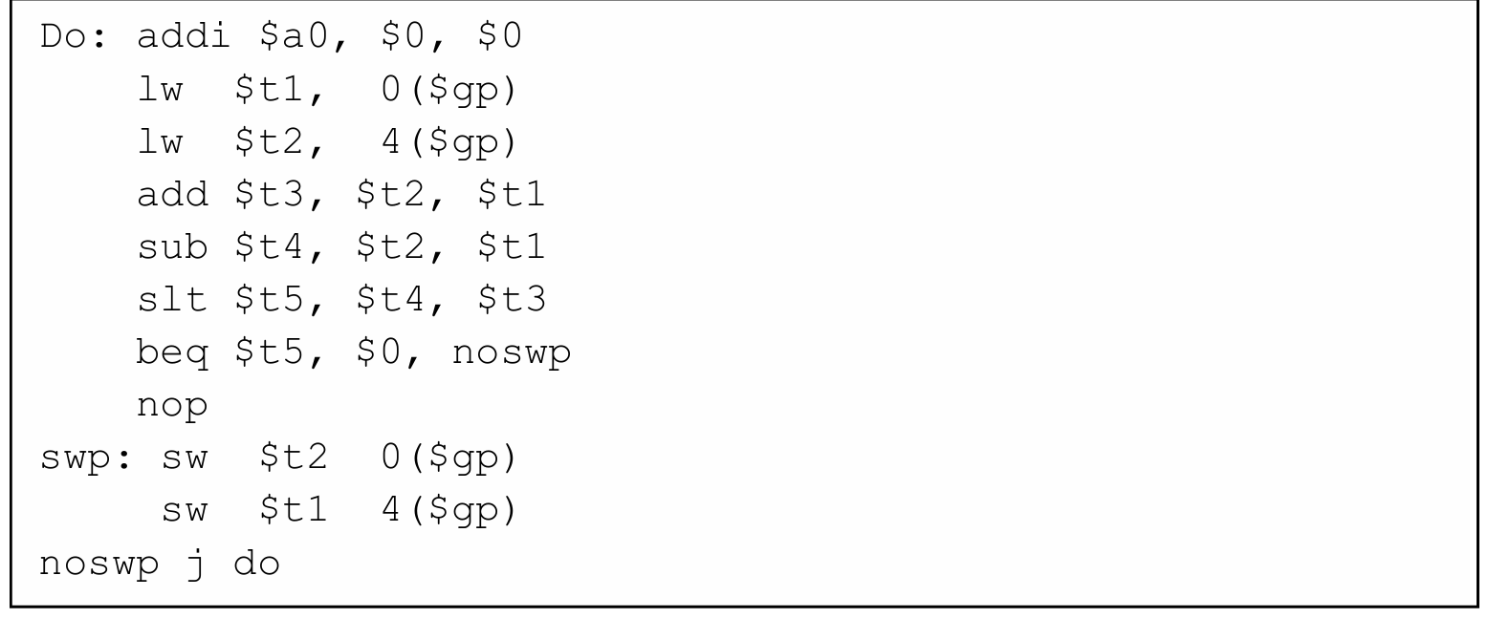
Sol. 6: So in order to write correct machine code, let’s allocate addresses to each instruction:
Address | Instruction
0x00400000 | addi $a0, $0, 0
0x00400004 | lw $t1, 0($gp)
0x00400008 | lw $t2, 4($gp)
0x0040000C | add $t3, $t2, $t1
0x00400010 | sub $t4, $t2, $t1
0x00400014 | slt $t5, $t4, $t3
0x00400018 | beq $t5, $0, noswp
0x0040001C | nop
0x00400020 | sw $t2 0($gp)
0x00400024 | sw $t1 4($gp)
0x00400028 | j Do

So, to refer how machine codes were formed, we can refer the following notes from notepad (a text file is also attached in the github)
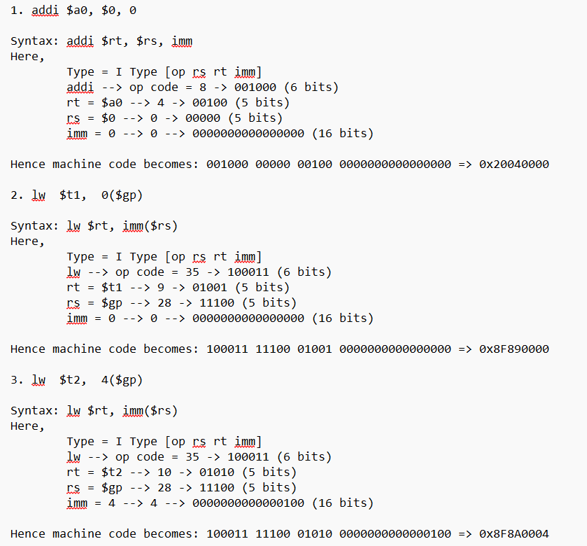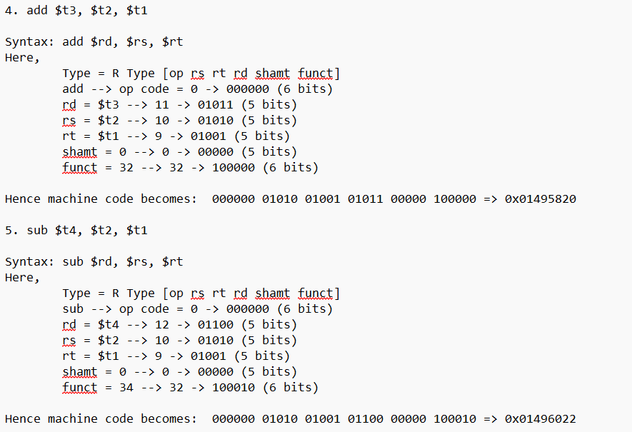
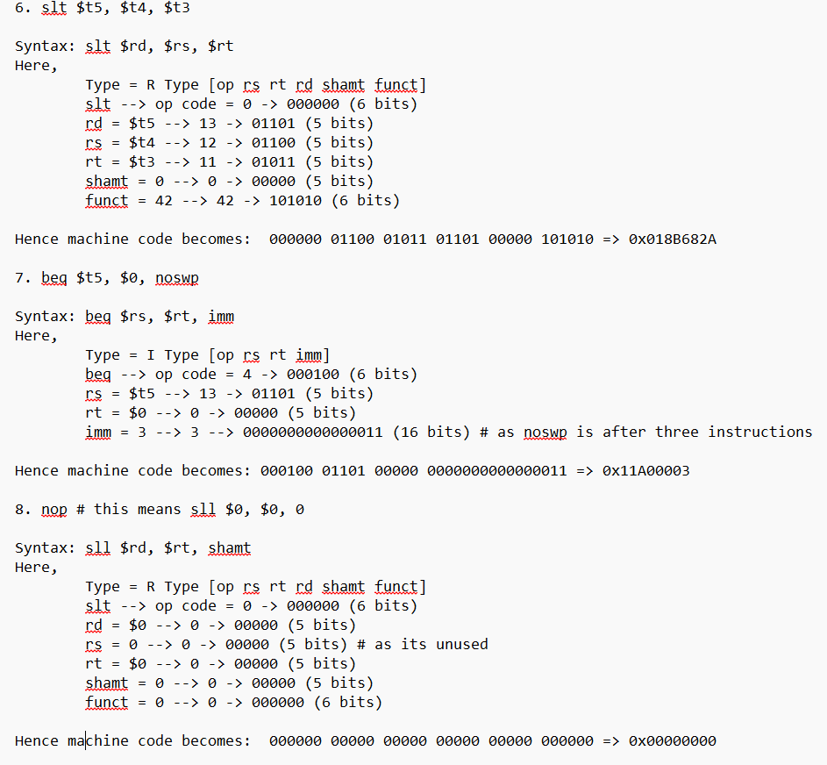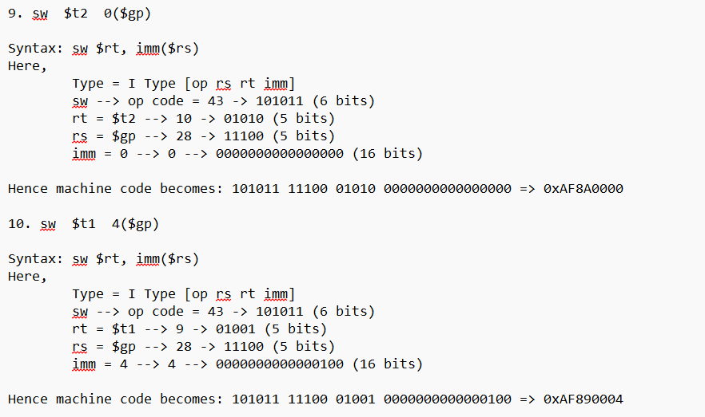
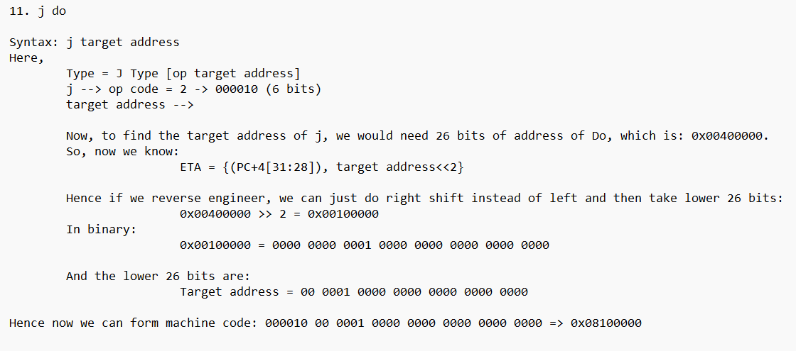
The machine code for the following program in assembly would be:
Binary Form:
0x00400000: 001000 00000 00100 0000000000000000
0x00400004: 100011 11100 01001 0000000000000000
0x00400008: 100011 11100 01010 0000000000000100
0x0040000C: 000000 01010 01001 01011 00000 100000
0x00400010: 000000 01010 01001 01100 00000 100010
0x00400014: 000000 01100 01011 01101 00000 101010
0x00400018: 000100 01101 00000 0000000000000011
0x0040001C: 000000 00000 00000 00000 00000 000000
0x00400020: 101011 11100 01010 0000000000000000
0x00400024: 101011 11100 01001 0000000000000100
0x00400028: 000010 00000100000000000000000000
Hexadecimal Form:
0x00400000: 0x20040000
0x00400004: 0x8F890000
0x00400008: 0x8F8A0004
0x0040000C: 0x01495820
0x00400010: 0x01496022
0x00400014: 0x018B682A
0x00400018: 0x11A00003
0x0040001C: 0x00000000
0x00400020: 0xAF8A0000
0x00400024: 0xAF890004
0x00400028: 0x08100000
֍֍֍֍֍֍

